Cable tray report

Cable tray name: {TrayName}

Cable tray type: Niedax {TrayType}

Cable tray purpose: {TrayPurpose}

# Cable tray dimensions:

Height: {TrayHeight} [mm], Width: {TrayWidth} [mm], Length: {TrayLength} [mm],

Weight: {TrayWeight} [kg/m],

# Cables laying on the tray:

{CablesTable}

# Weight calculations:

## Supports weight calculations:

The supports weight calculations depend on the distance between the supports based on the tray length and the count. For “{TrayType}” type the maximal distance between two supports is {Distance} meters. For trays that the length is less than {Distance} meters, we have 2 pieces of supports. For trays that the length is bigger than 20% from the base {Distance} meters, there is additional support.

Supports count: {SupportsCount},

Weight per piece: {SupportWeight} [kg]

The total weight of the supports is calculated by the count of the supports, multiplied by the weight per piece:

Supports total weight: {SuppTotalWeight}

The total weight per meter is calculated by division of the tray length and the total weight of the supports:

Supports weight load per meter: {SuppWeightPerMeter}

## Tray own weight calculations:

Tray weight load per meter is calculated by the sum of cable tray weight and support weight per meter:

Tray weight load per meter: {TrayLoadPerMeter}

Total tray weight is calculated by combining the own weight per meter with added supports weight per meter, then multiplied by the tray total length.

Tray total own weight: {TrayWeightCalcs}

## Cables on tray weight calculations:

Cables weight load per meter is calculated by the sum of cables weight per meter:

Cables weight load per meter: {CablesWeightPerMeter}

Total weight of all the cables on the tray is the sum of the cables weights.

Total weight on the tray: {CablesWeightCalculations}

## Total weight:

Total weight load per meter: {TotalPerPoint}

Total weight: {TotalCalc}

{DiagramTrayPic}

Picture 1. – Load per meters diagram regarding the distance between the supports.

# Free space calculations:

All trays “{TrayType}” type are ladder type trays. Rung spacing 300 [mm], with continuously perforated side rails, with riveted, upwardly open rungs made of C-profiles.

{TrayPicture}

Picture 2. – Cable tray type overview.

Tray board height is {TrayHeight} [mm], but the C-profiles occupy a part of the volume space. So, the useful height for the tray is {TrayHeight} – 15 = {TrayHeightFormula} [mm]. Medium voltage cables are laid and grouped in a triangle (“trefoil”) formation, forming each a 3-phase system.

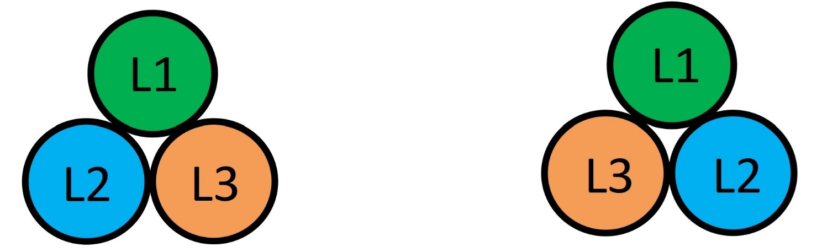

Picture 3. – Trefoil cables formation type overview.

The minimum distance of cable bundle/trefoil is 2x outer cable diameter (2d). Between parallel laid power cables minimum distances have to be complied with along the entire laying distance (except for building-pass-through / penetrations). Power cables laid in parallel shall have the same cable lengths. A maximum cable length difference of 3% can be accepted if properly considered in cable dimensioning (de-rating). No free space is considered.

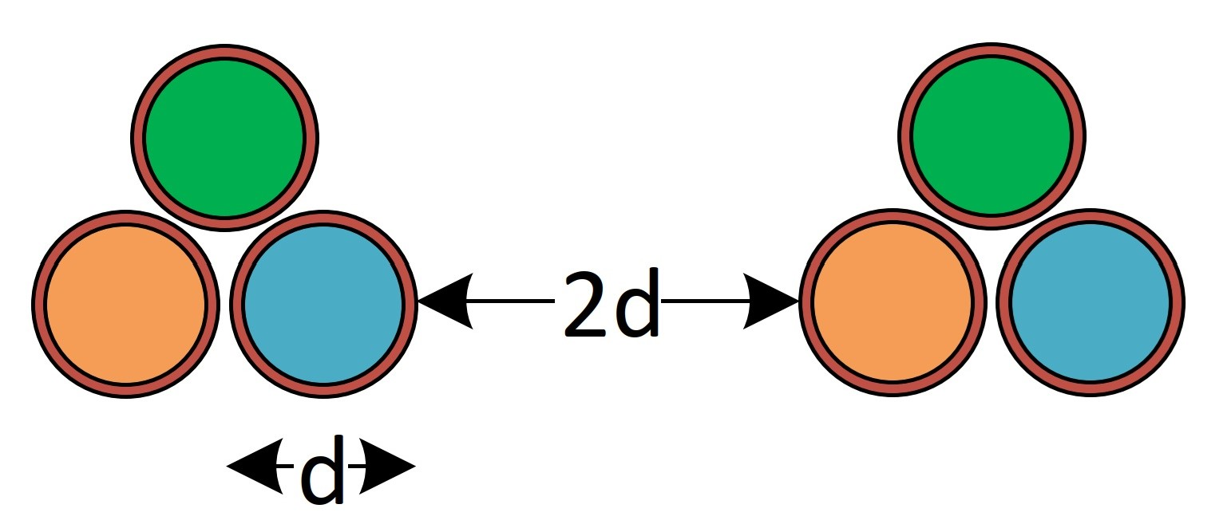

Picture 4. – Minimum distance of cable trefoil.

{FillPicture}